Artificial Intelligence Lab

Lab tutorial 1

Application of graphs

**Sample 1: (for solving a puzzle)**

The Missionaries and Cannibals problem is a classic AI puzzle that can be defined as follows:

On one bank of a river are three missionaries and three cannibals. There is one boat available that can hold up to two people and that they would like to use to cross the river. If the cannibals ever out-number the missionaries on either of the river’s banks, the missionaries will get eaten.

How can the boat be used to safely carry all the missionaries and cannibals across the river?

The initial state is shown to the right here, where black triangles represent missionaries and red circles represent cannibals.

**Searching for a Solution**

This problem can be solved by searching for a solution, which is a sequence of actions that leads from the initial state to the goal state. The goal state is effectively a mirror image of the initial state. The complete search space is shown in figure 1.

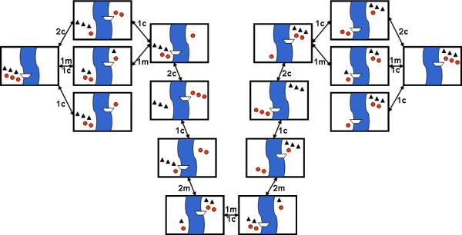

Figure 1: Search-space for the Missionaries and Cannibals problem

Arrows in figure 1 represent state transitions and are labelled with actions, e.g. 2c represents the action of two cannibals crossing the river. The initial state is shown again on the left, whereas the goal state is all the way to the right.

**Problem 1:** You are given two jugs, a 4-gallon one and a 3-gallon one. Neither has any measuring mark on it. There is a pump that can be used to fill the jugs with water. How can you get exactly 2 gallons of water into the 4-gallon jug

Give state space representation for Water Jug problem

**Problem 2:**  A wolf, a goat, a cabbage, and a farmer are on the west bank of a river and wish to cross to the east side, but only have a boat that can fit the farmer and one other thing. The wolf will eat the goat if the farmer leaves them alone and the goat will eat the cabbage if left alone. How can the farmer bring everything across to the east bank?

Give state space representation.